Consolidated Change Request (UAT)
SIPRI Integration with Jal Rekha SVS Anushravan Module
Document | Complete and finalised change request – both modules in one document
Modules covered | A. SIPRI mobile app (Jal Rekha SVS Anushravan) | B. Jal Rekha SVS Anushravan web reports
Date | 09 October 2026
Total change items | 14 (Module A: 12, Module B: 2)
Prepared by | MPSeDC – MPSSDI/GIS Division

1. Purpose
This document consolidates all changes identified during UAT across both modules into a single list, so that the impact can be assessed and the changes implemented together. It is intended to avoid repeated modifications and to minimise disruption and instability for existing SIPRI users.
Changes in names, labels and messages are against the wireframes approved earlier and are marked here as the final required wording. Please treat this as the complete set of changes for this cycle.

2. Module A – SIPRI mobile app (Jal Rekha SVS Anushravan)
Ref | Screen / Area | Login / Role | Observed in UAT | Required change
A1 | App – module name | All users | Module name inside the SIPRI app is shown as "Jal Nigam GP". | Display the module name as "ANUSHRAVAN". Do not use "Jal Nigam GP". Correct spelling is "Anushravan".
A2 | App – user designation | Sub Engineer (SE) | User designation is shown as "Jal Nigam FE". | Display the designation as "Sub Engineer". Do not use "Jal Nigam FE".
A3 | RFI status | GP / SE | After the RFI is accepted or rejected, the status still shows "Verify". | Show "Verified" only after the RFI inspection has been completed.
A4 | RFI submission – confirmation | SE | The confirmation pop-up reads "Site approved successfully by SE" (Screenshot 3). | On submission, display the message "RFI submitted successfully".
A5 | RFI History | SE | The RFI History list / tab is not visible after a successful RFI submission. | Make the RFI History tab and list available at SE login after submission.
A6 | RFI History – remarks | GP | Field Engineer remarks are not visible in the GP login history. | Display the remarks entered by the Field Engineer in the GP RFI History.
A7 | RFI History – photographs | GP | After the RFI is attended, only one photograph is available in the history. | Display both photographs in the GP login history: the "GP Field Photo" and the "Field Engineer (FE) Field Photo".
A8 | RFI History – GP photo button | GP | After the RFI request is submitted, the GP photo cannot be viewed in RFI History. | Make the photo viewable in RFI History under GP login. Name the button "GP Field Photo".
A9 | Photo viewing | GP / SE | Photos open as a URL / file download (Screenshot 4: "Choose where to download"). | View photos in the app as an image (jpg). Do not present them as a URL or a download.
A10 | RFI create request form | GP | The form is displayed in English. | Provide the RFI create request form in Hindi.
A11 | Village dropdown | GP | Villages show under the dummy user but not under the GP user ID; the alert "No village found for your Gram Panchayat. Do you want to retry?" appears (Screenshot 2). | Fix the village list for GP users. For verification, genuine GP user credentials and the registered mobile number are to be shared for login.
A12 | FE form submission | FE | Submitting the verification form for RFI Id 18 fails with the error: relation "pnrd.res_jranu_site" does not exist (Screenshot 1). | Resolve the database error so the Field Engineer can submit the form successfully.

3. Module B – Jal Rekha SVS Anushravan web reports
Ref | Screen / Area | Login / Role | Observed in UAT | Required change
B1 | Reports – Sub Category | Web user (GP login) | The Sub Category column shows Null / empty values. Null in Sub Category also needs a database check. | Populate the Sub Category column correctly in reports after checking the underlying data.
B2 | Reports – access | All web user logins | Reports are not visible to all web user logins that have been created. | Make the report available and visible to all web user logins.

4. Points for confirmation
C1 | "Date of inspection" appears in the source notes without any description of the required change. Please confirm what is expected (field, label, format or display).
C2 | Confirm the source of the "Sub Category" Null values (database mapping or report query) and whether the app and web reports are both affected.
C3 | Genuine GP user credentials and registered mobile numbers are required to verify the village dropdown (A11).

5. Reference screenshots
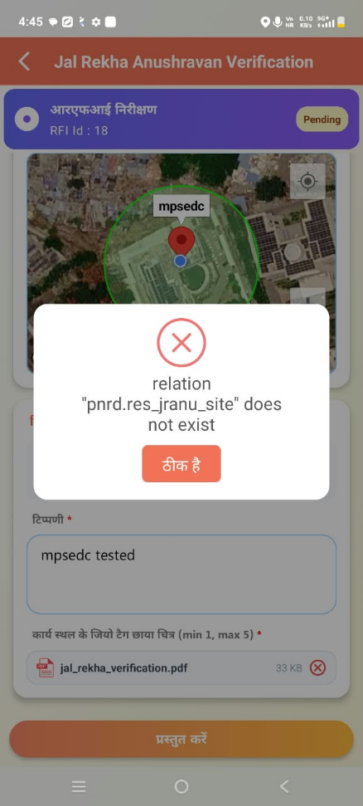  Screenshot 1: FE submit error (A12) | 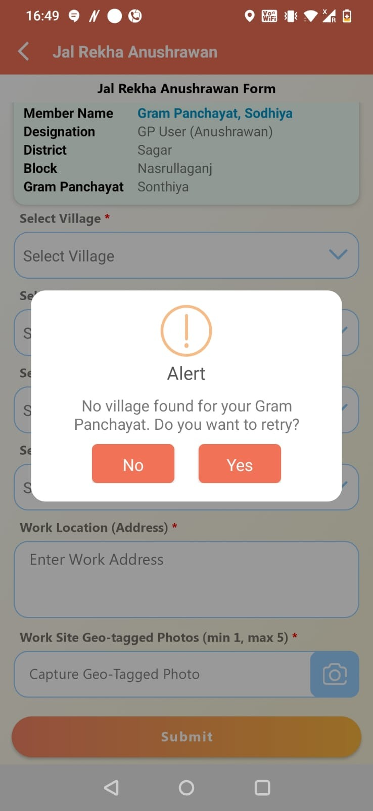  Screenshot 2: No village found, GP login (A11) | 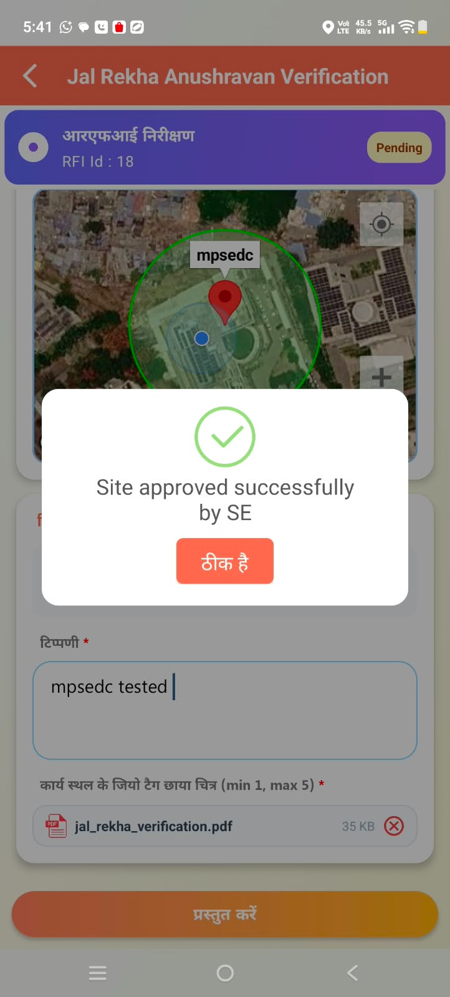  Screenshot 3: Confirmation text to change (A4) | 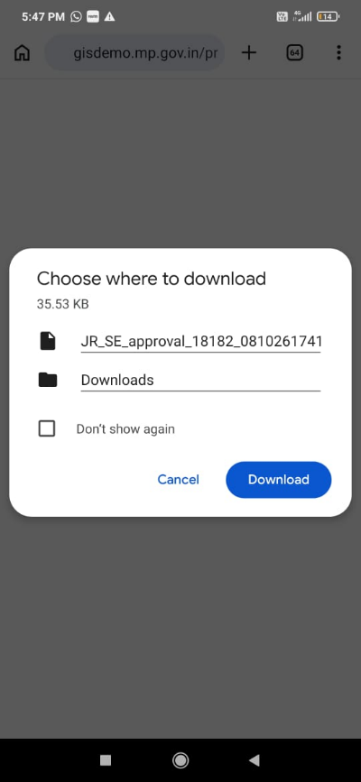  Screenshot 4: Photo download prompt (A9)

